# Firewall And Routing

**Firewall – Summary and Key Points**

**🔹 Definition**

A **firewall** is a network security device (hardware or software) that monitors and controls **incoming and outgoing traffic** based on **predefined security rules**.  
It acts as a **security guard** between your internal network and the outside world.

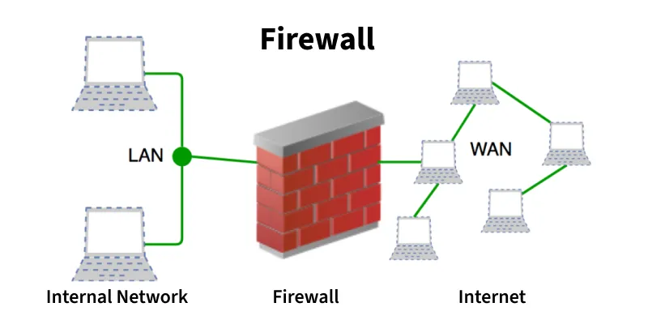

**🔹 Firewall Actions**

* **Accept:** Allow the traffic.
* **Reject:** Block the traffic but send an “unreachable” message.
* **Drop:** Block the traffic silently (no reply).

**🔹 Need for a Firewall**

1. **Prevent Unauthorized Access** – Keeps intruders out, like locking a door.
2. **Block Malicious Traffic** – Stops harmful or spam data.
3. **Protect Sensitive Data** – Keeps personal/business info safe.
4. **Prevent Cyber Attacks** – Defends against hackers and malware.
5. **Control Network Usage** – Limits what websites or services can be accessed.

**🔹 Working of a Firewall**

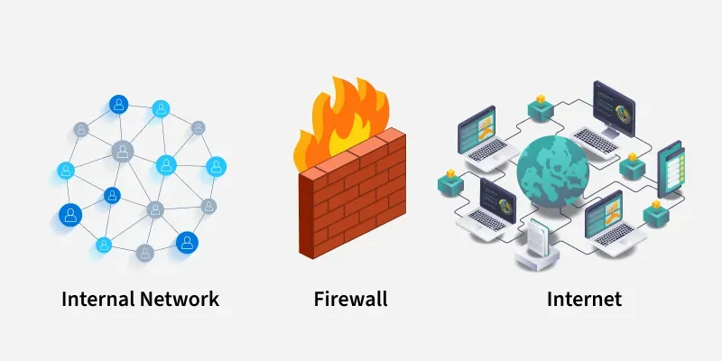

1. All data entering/leaving passes through the firewall.
2. Firewall checks packets against **security rules**.
3. **Allow or block** decisions are made.
4. **Logs and alerts** are generated for unusual activity.
5. **Default policy:** If no rule matches, follow *default action* (best practice: set to **drop**).

**🔹 Types of Firewalls**

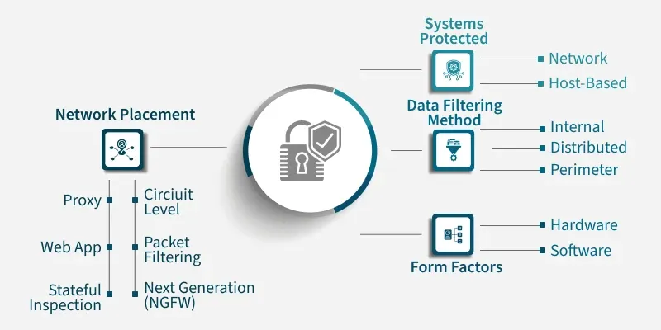

**1. Based on Network Placement**

* Packet Filtering Firewall
* Stateful Inspection Firewall
* Proxy (Application-Level) Firewall
* Circuit-Level Gateway
* Web Application Firewall (WAF)
* Next-Generation Firewall (NGFW)

**2. Based on System Protected**

* Network Firewall
* Host-Based Firewall

**3. Based on Data Filtering**

* Perimeter Firewall
* Internal Firewall
* Distributed Firewall

**4. Based on Form Factor**

* Hardware Firewall
* Software Firewall

**🔹 Importance**

* Acts as **first line of defense** against cyber threats.
* Filters traffic to prevent **unauthorized access**, **malware**, and **data leaks**.
* Essential for **secure communication** and **network control**.

**🔹 History (Evolution)**

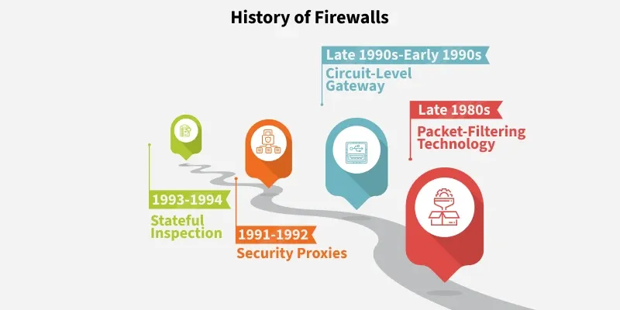

* **1980s:** Packet Filtering – DEC Corporation.
* **Early 1990s:** Circuit-Level Gateways – AT&T Bell Labs.
* **1991–1992:** Application Firewalls (SEAL) – Marcus Ranum.
* **1993–1994:** Stateful Inspection – Check Point (Gil Shwed).

**🔹 Firewall Functions**

* **Monitors** and **filters** traffic.
* **Logs** and reports blocked activities.
* **Reduces attack surface** by being the only entry/exit point.
* **Prevents** both **external** (hackers, malware) and **internal** threats (unauthorized apps).

**🔹 Firewall Protects Against**

* Hackers, malware, and phishing attacks.
* Unauthorized network access.
* Data leaks or exfiltration.
* Inappropriate web content (via filters).
* Misuse of company networks or resources.

**🔹 Firewall Security Best Practices**

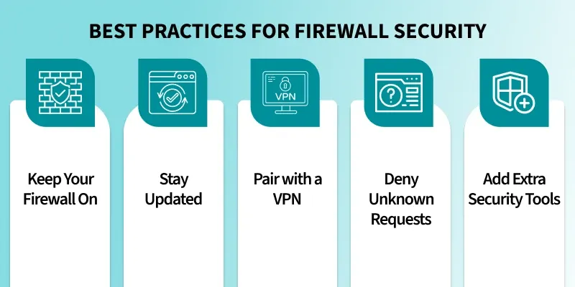

1. Always **keep the firewall enabled**.
2. **Regularly update** firewall software and firmware.
3. Use **strong security rules** and review them often.
4. Combine with **VPN** for added encryption.
5. **Monitor logs** for unusual activity.

**What is Routing :**

* Routing is the process of **selecting the best path** for data packets to travel across one or more networks — from **source to destination**.  
  It ensures efficient and reliable communication in **packet-switched networks (like the Internet)**.
* A **router** is a **network device** that forwards data packets between networks.
* Works on **Layer 3 (Network Layer)** of the OSI model.
* Uses **IP addresses** to determine the best route.
* Connects multiple networks (e.g., LAN to WAN).

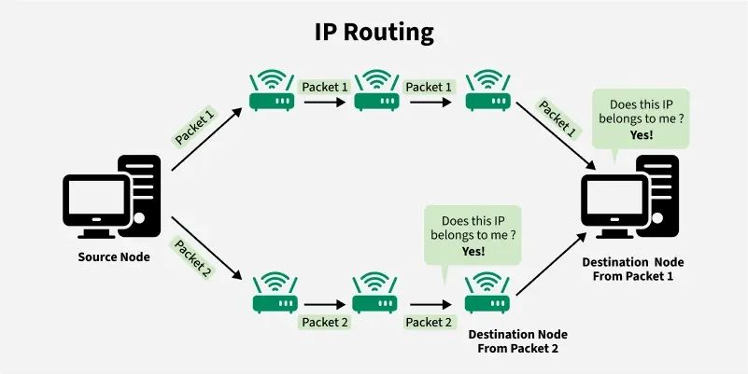

**🔹 How Routing Works**

1. **Source node** sends packets with destination IP in the header.
2. **Router** reads the IP, checks its **routing table**, and decides the next hop.
3. Packets move **hop by hop** until reaching the **destination node**.
4. **Hop count** limits how many routers a packet can cross; if exceeded, packet is dropped.

**🔹 Types of Routing**

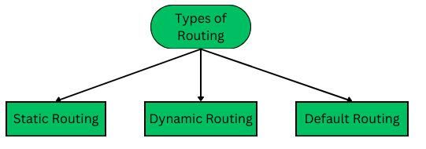

1. **Static Routing** –
   * Routes set **manually** by admin.
   * Best for **small networks**.
   * Full control but not scalable.
2. **Dynamic Routing** –
   * Routes **automatically updated** using algorithms.
   * Adapts to network changes.
   * Best for **large networks**.
3. **Default Routing** –
   * Used when no specific route is found.
   * Packets sent to a **default gateway (0.0.0.0/0)**.
   * Common in small or single-exit networks.

**🔹 Routing Process (Step-by-Step)**

1. **Communication starts** between source and destination.
2. Data is **split into packets** with IP headers.
3. Routers consult **routing tables** to find the best path.
4. Packets move through **multiple hops**.
5. At the destination, packets are **reassembled** and checked for errors.

**🔹 Main Routing Protocols**

| **Protocol** | **Type** | **Description** |
| --- | --- | --- |
| **RIP** | Distance Vector | Uses hop count as metric. |
| **OSPF** | Link State | Uses Dijkstra’s algorithm. |
| **EIGRP** | Hybrid | Combines distance-vector and link-state. |
| **BGP** | Path Vector | Used for routing between ISPs. |
| **IS-IS** | Link State | Common in large enterprise networks. |

**🔹 Routing Metrics**

Metrics help determine the **best path** for data:

1. **Hop Count** – Fewer hops = better route.
2. **Bandwidth** – Higher bandwidth = faster transmission.
3. **Delay** – Lower delay = faster delivery.
4. **Load** – Less traffic = more efficient route.
5. **Reliability** – Stable links preferred.

**🔹 Types of Routing Protocols**

1. **Distance Vector Routing** – Shares routing tables with neighbors.
   * Uses **Bellman-Ford Algorithm**.
   * Example: RIP.
2. **Link State Routing** – Shares updates only when network changes.
   * Uses **Dijkstra’s Algorithm**.
   * Example: OSPF, IS-IS.

**🔹 Advantages of Routing**

* Highly **scalable** for large networks.
* Enables **load balancing** and **efficient data delivery**.
* Supports **automated route management** (in dynamic routing).

**🔹 Disadvantages of Routing**

* **Static routing:** Not scalable, hard to manage.
* **Dynamic routing:** Uses more CPU, memory, and bandwidth.
* **Default routing:** Can be risky if not configured properly.